|  |  |
| --- | --- |
| **AGENDA - Little Hoole Parish Council**  *Members of the Council are summoned to the Parish Council Meeting to be held on  Mon 10th Feb 2025 at 7:00pm*  ***The Lounge, Walmer Bridge Village Hall, Gill Lane, PR4 5GN*** Paul Cafferkey, Clerk & Responsible Financial Officer |  |

1. Apologies for absence
2. To agree the Minutes of the last Parish Council Meeting
3. To receive declarations of interest
4. Matters arising from the minutes of last meeting
   1. Public Time: to invite and listen to issues raised by members of the public.
   2. To consider grant application from Walmer Bridge Village Hall, in the sum of £3,518 (inclusive of VAT), towards the purchase of 2 professional marquees.
   3. Planning Applications:
5. 07/2024/00950/HOH. The Mill 47 Jubilee Road Walmer Bridge PR4 5QW. Single storey side extension to include chimney together with the repositioning of the existing boundary wall closer to the highway (amended description)
6. 07/2024/00889/FUL. Carver Hey Farm Moss Lane Little Hoole PR4 4SX. Demolition of Existing Buildings and Erection of 9 Detached Dwellings
   1. Payments for approval - Clerk’s claim for Jan 2025
   2. Payments approved by email or pre-approved and retrospectively noted – Replacement Pads for Defibrillator.
   3. To ratify the gifting of professional lawn mower to Hoole Bowling Club.
   4. PTA Grant – Update.
   5. To review and re-approve Standing Order & Financial Regulation.
   6. To review and re-approve HR Policies.
   7. To approve entry into Lancashire Best Kept Village Competition
   8. To discuss feasibility of a Community Orchard
   9. Update re Zip Wire project – if applicable
   10. To discuss adoption of .gov.uk email addresses
   11. Information and Updates.
   12. Correspondence – email re Dog Fouling
   13. To agree the date, time, and venue for the March 2025 meeting.

**Members of the public are welcome to attend meetings to raise any relevant matters. Alternatively, if you cannot attend the meeting but wish to raise a matter or ask a question, this can be done on your behalf by contacting the Parish Clerk (Paul Cafferkey) via email at** [**clerk@littlehooleparishcouncil.org.uk**](mailto:clerk@littlehooleparishcouncil.org.uk) **or mobile phone 07966267186.**

Scan me to go the Little Hoole Parish Council Website, or visit <https://www.littlehooleparishcouncil.org.uk/>

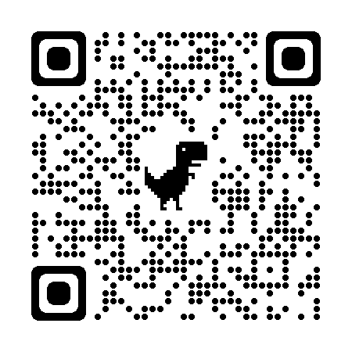

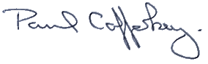Prepared and approved by Paul Cafferkey, Clerk – Little Hoole Parish Council,   
31st Jan 2025